Liquid Light

## A How-To Guide

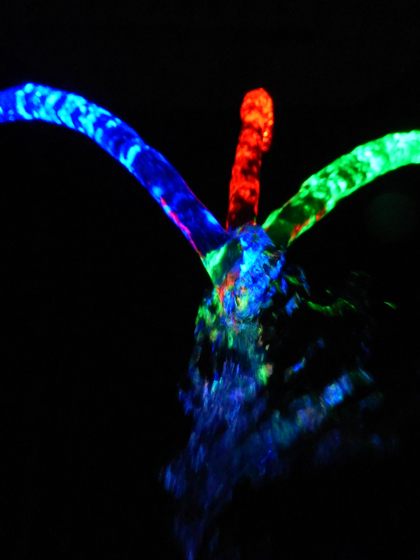

# Foreword

Liquid Light is designed to get kids interested about light, reflection, as well as water systems: pumps, pressure, etc. The light travels with the water via a similar method to how fiber-optics work, using water as the medium of transmission for internal reflection.

The building blocks of the design are described here in the guide, but are meant to be stepping stones to larger, more personalized projects. Fittings can be swapped, new pieces can be made, different LEDs can be used, etc. The real engineering comes through experimentation. Our own experimentation means you’ll see pictures of different designs and materials throughout this guide.

For safety, do also remember that power tools will be used in construction, and we are dealing with water and electronics. Respect for tools and each other in a shop space is essential, and should be instilled early in the class.

# Materials

* 1” white PVC pipe
* 1” PVC pipe fittings
  + 90° elbow
  + 3-way “T”
  + In-line connector
  + Flange endcap
* 3/8” brass fittings
  + 90° elbow (Male-Female)
  + Plug
  + Nozzle
* Teflon tape
* 1” clear PVC pipe
* Red/Green/Blue/Etc LEDs
* *Optional*: Color-changing LEDs
* Assorted resistors
* 500 gph bilge pump
* Flexible plastic tubing
* 12V Power Supply
* 9V Batteries and Battery snaps
* Stranded hookup wire
* Electrical tape
* Reservoir (*from Stream Tables*)
* Rags

# Tools

* Band saw/Hack saws/PVC cutters
* 3/8” NPT Drill and Tap set
* 3/16” drill bit
* Hand drill/drill press
* Bench and table vises
* Hot glue gun
* Wire strippers
* Soldering stations
  + Soldering iron
  + Helping hands
  + Brass tip cleaners
  + Solder

# Part One: Setting Up Building Blocks

1. Cut both your white and clear PVC pipe into usable lengths. We recommend a good mix of 2-3 sizes so that you have options of small, medium, and/or large. For example, you could have pieces 6”, 12”, and 18” long.
2. Drill and tap along one side of each piece, leaving at least 4” between any two taps. (This means short pieces likely only have one tap, whereas medium or large may have 2 or 3.) Make sure to be as perpendicular to the surface of the pipe as you can.
3. Test your taps by threading in a plug fitting. The fitting should thread in **very easily**, with practically no resistance for the first few turns. The threads can be fragile, so be **very gentle** and ensure you are in line with the tap.

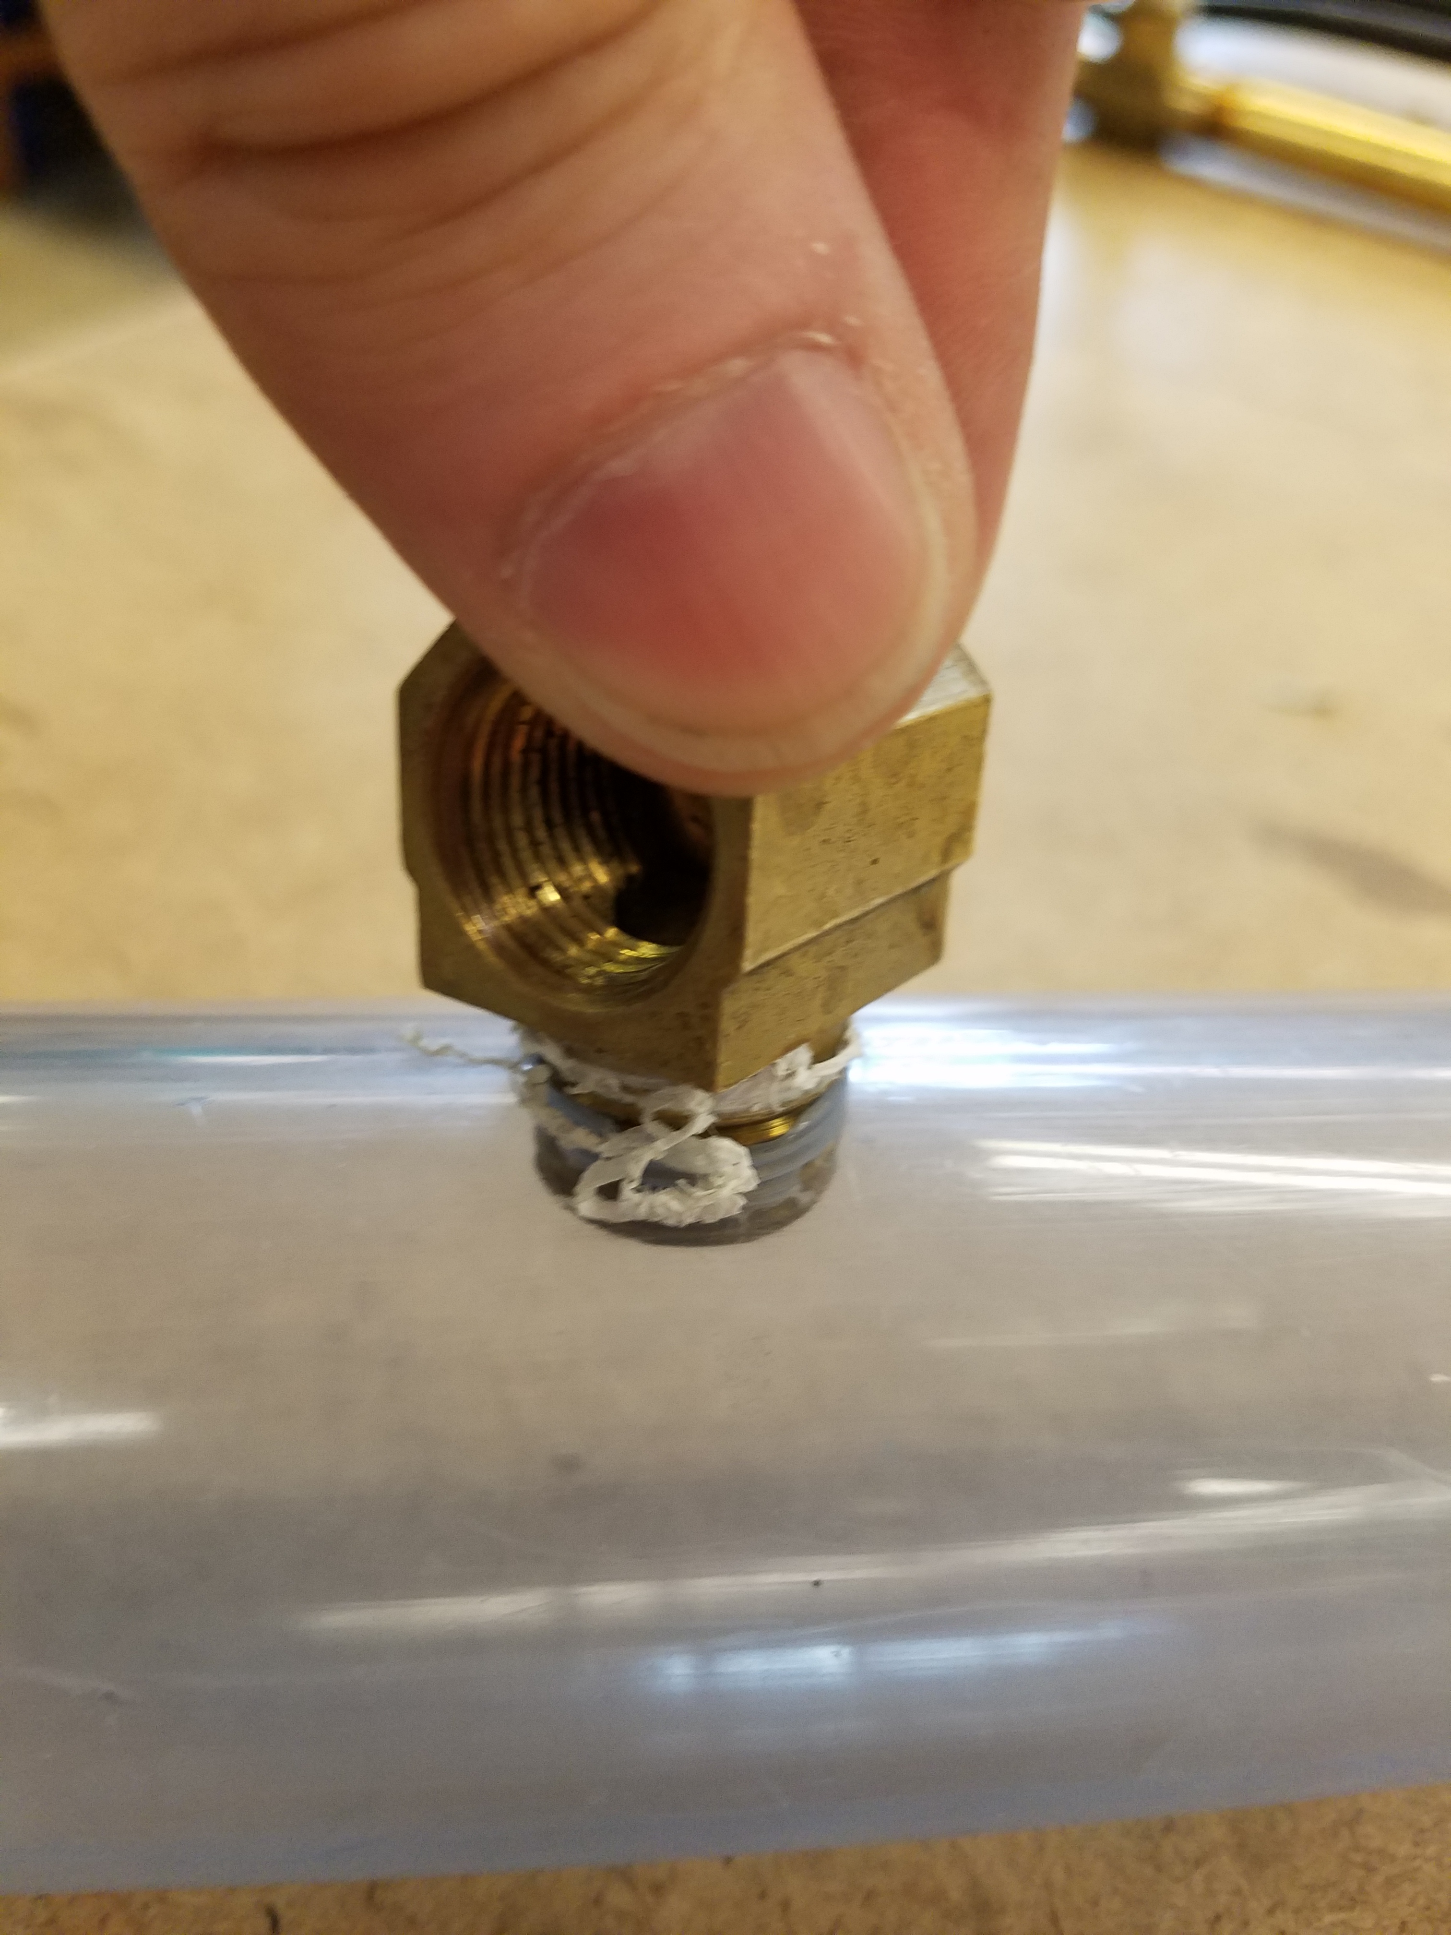

1. To get a better seal, you can also add Teflon tape to the threads of your fittings, as seen in the picture above. This will increase the resistance you feel when threading the fittings, so practice getting the feel for when things are being done correctly.

# Part Two: Liquid Without Light

1. To test your fittings and your pumps, start by taking your building blocks and build a simple “fountain”. An easy way to do this is to take 3 pieces of PVC, as well as 2 elbow joints, and make the U-shaped design see below.

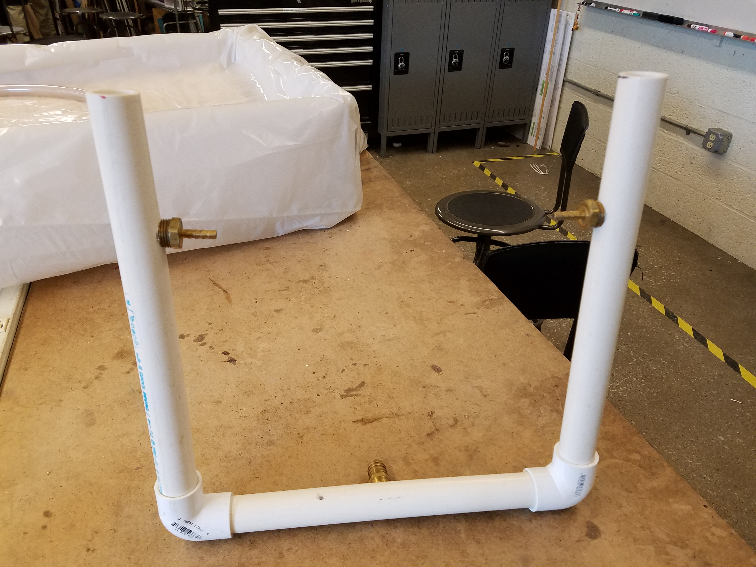

1. After putting the desired nozzles (the above uses one on each side) and an intake from the pump (above: bottom center), plug any remaining holes with the plug fittings (as seen below):

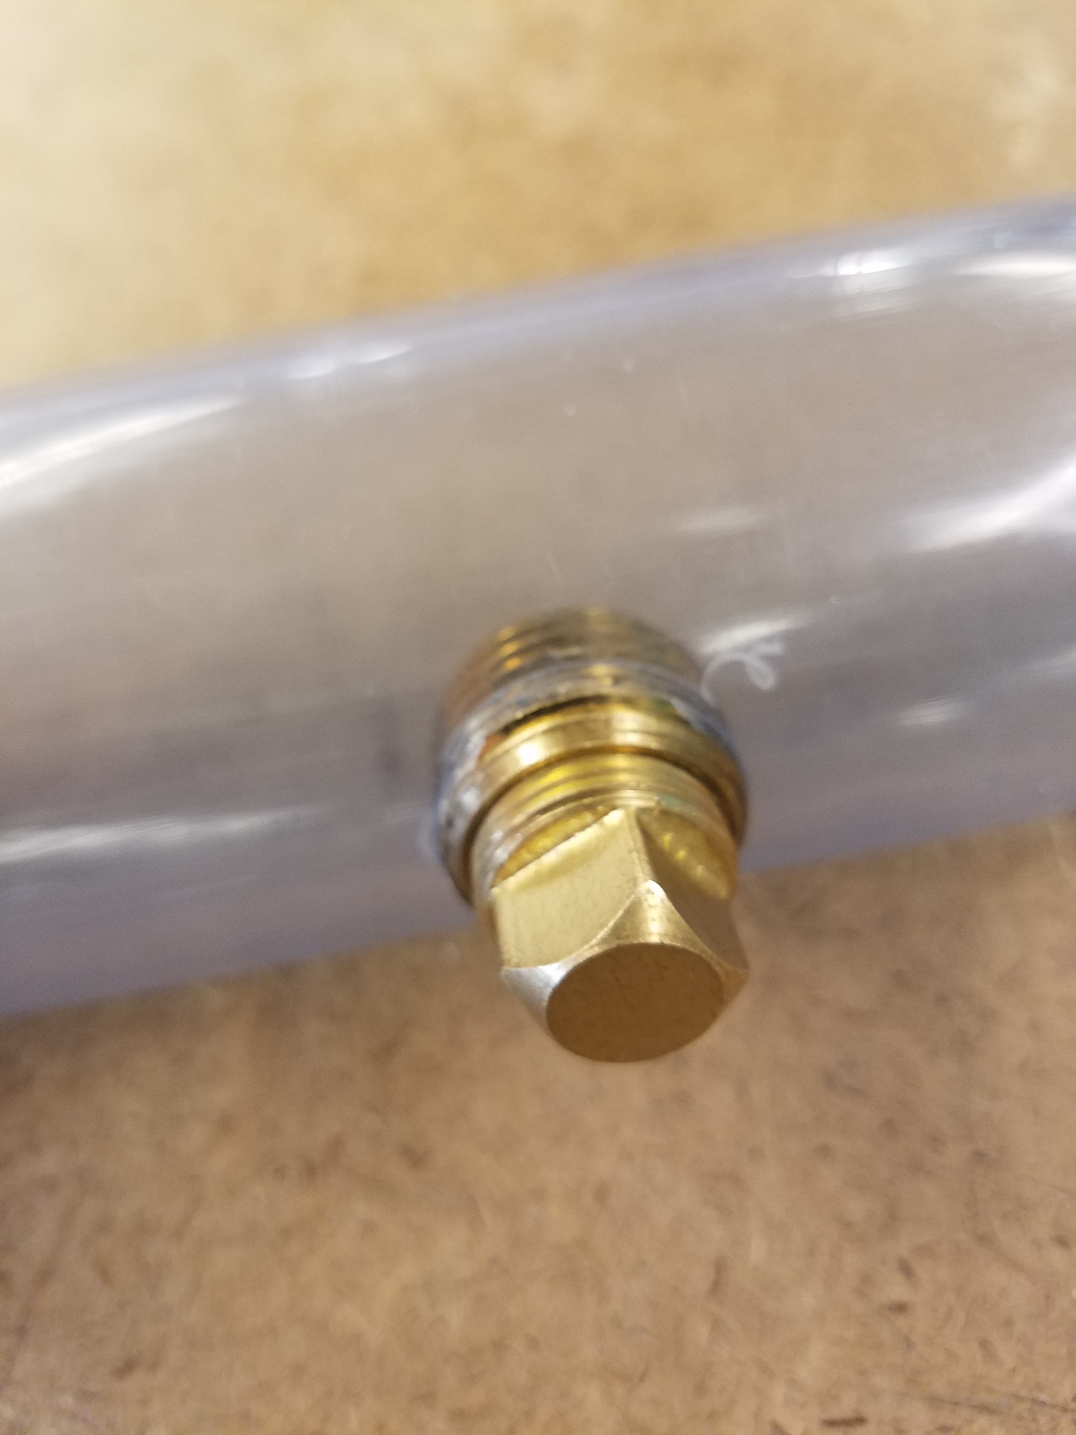

1. Attach your bilge pump to the intake (either directly or via a short piece of flexible tubing).
2. Move your assembly into your reservoir and fill your reservoir with water until the level reaches just below the output of the pump (about 1/3 of the way up the pump).
3. **Before** plugging in the pump, make sure that your nozzles are facing into the reservoir! Water will sometimes flow with more force than you expect, so be prepared to quickly turn it back off again.
4. Attach the wires from your bilge pump to your 12 V power supply, and begin running the pump. You want the flow from the pump to be smooth and without sputtering. If you see or hear sputtering, increase the water level in your reservoir.
5. Ideally, the water will also be flowing out of the top of the rig, as well as out the nozzles.
6. Check for leaks and evaluate the flow rate of the water through your rig. Try out different fittings and different locations, noting the changes between them. You can also replace some of your PVC pieces with longer or shorter ones and note the difference. Remember, there’s no reason your setup has to be symmetrical either. Take this opportunity to see how the water behaves before worrying about adding light.

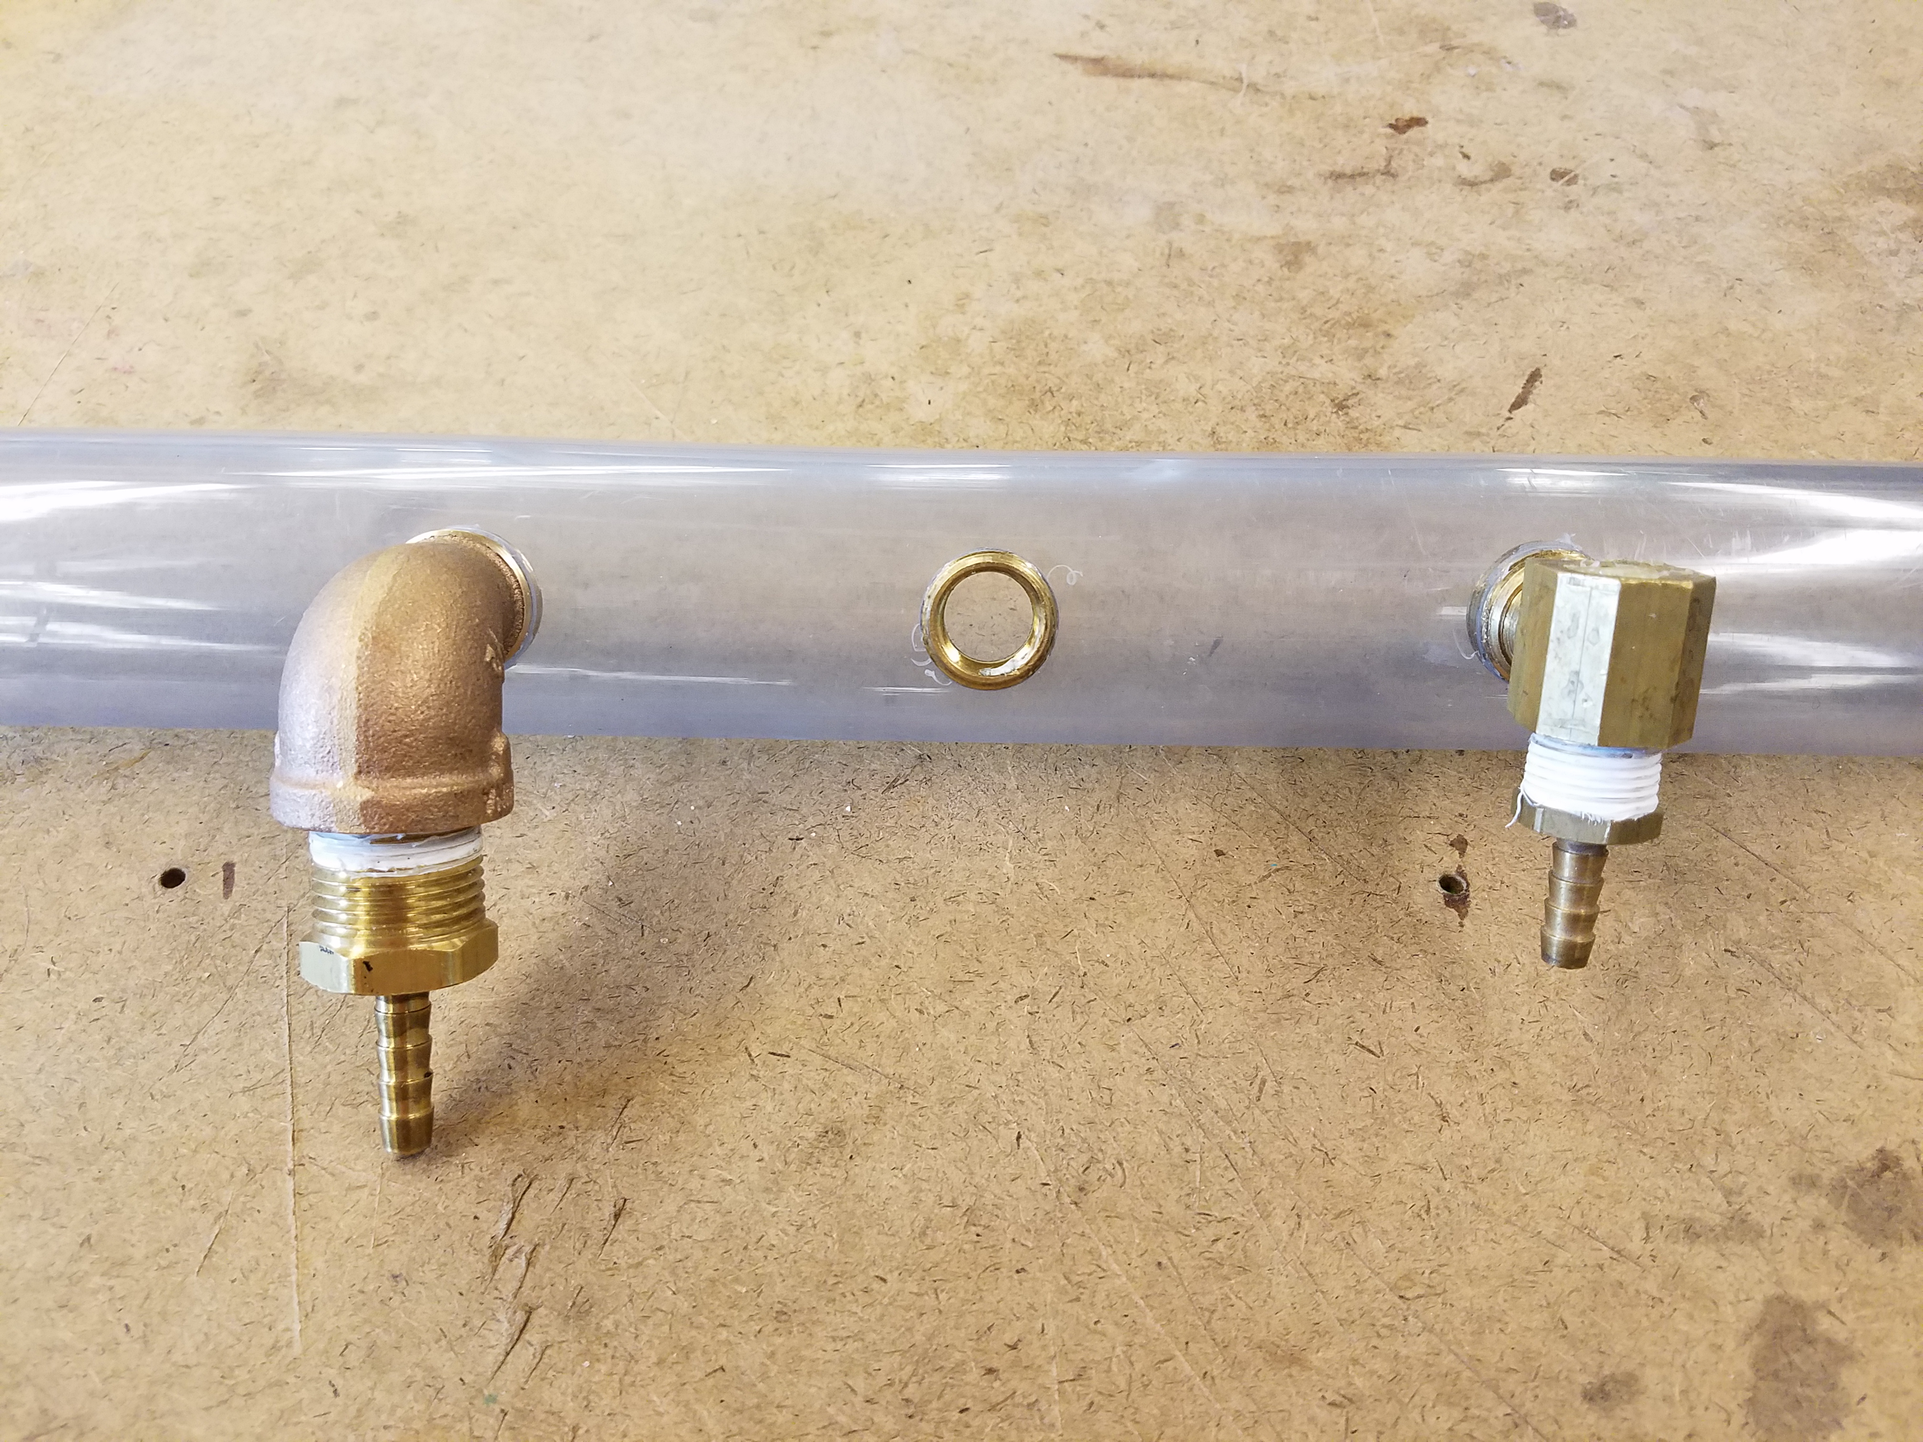

# Part Three: Setting up the Electronics

1. Bearing in mind the direction that the water will flow from the fitting, drill a hole for the LED (3/16” drill bit). The hole should be in-line with the direction of water flow. In the picture below, you can see the hole (drilled through the top) is in line with the nozzle (pointing down).

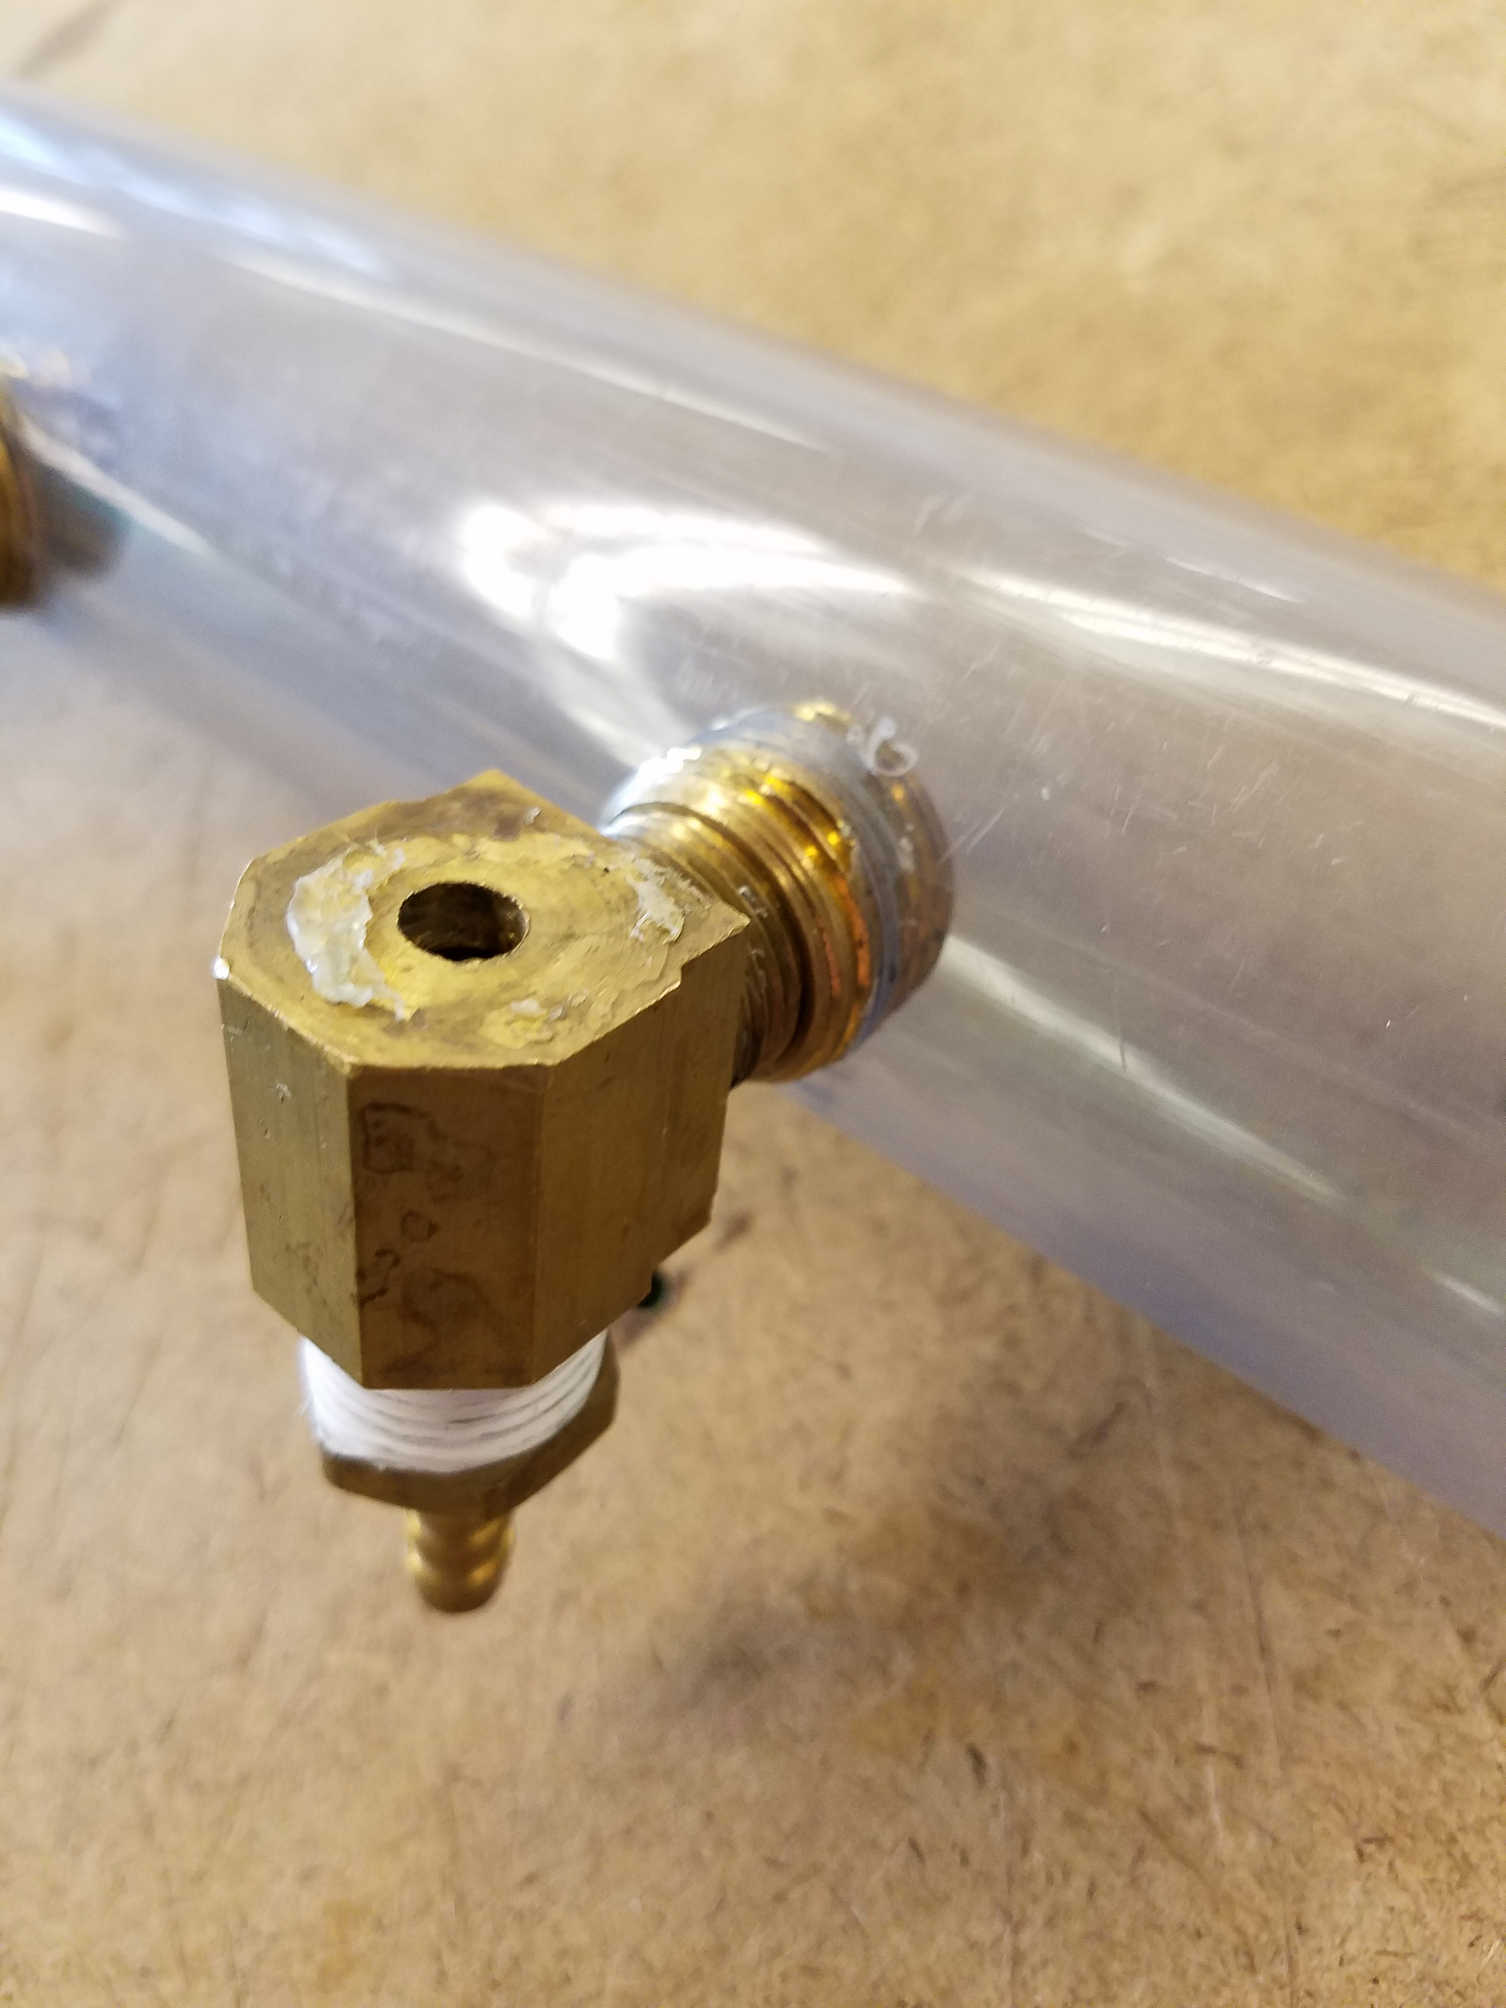

1. Now the LED can be placed in the fitting and hot glued in place. Aim the LED in the direction of the water flow (as shown below) and leave enough of each leg outside of the hot glue so that they can be soldered to later.

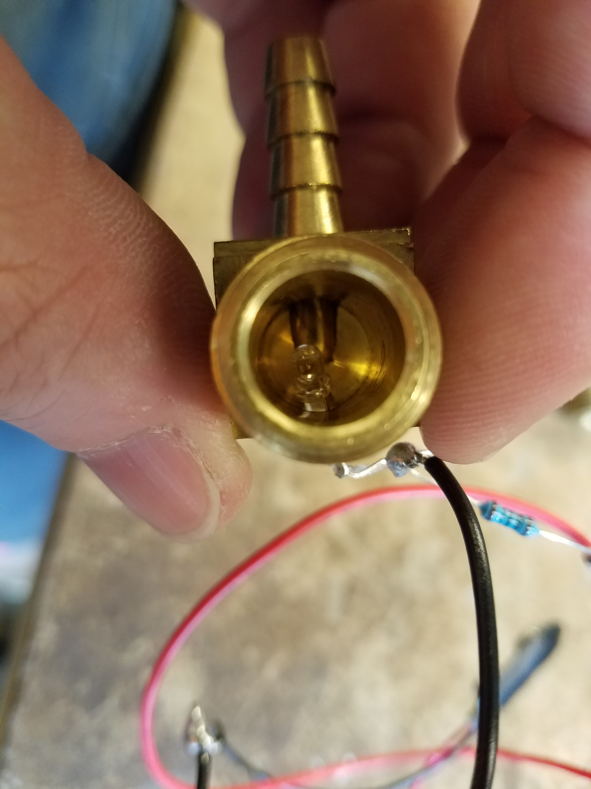

1. Create a LED tester by soldering a 220 Ohm resistor to the positive end of a 9V battery snap. Plug a 9V battery into the snap, and then you can touch the leads to the legs of the LED, making sure to link positive to positive and negative to negative. Remember that the positive leg of the LED is the longer one, and the notch in the plastic denotes the negative leg (see diagram below):

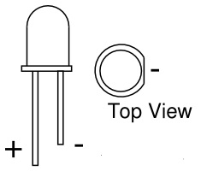

1. When the LED is powered, you should be able to see light going out the nozzle of your fitting, as shown below:

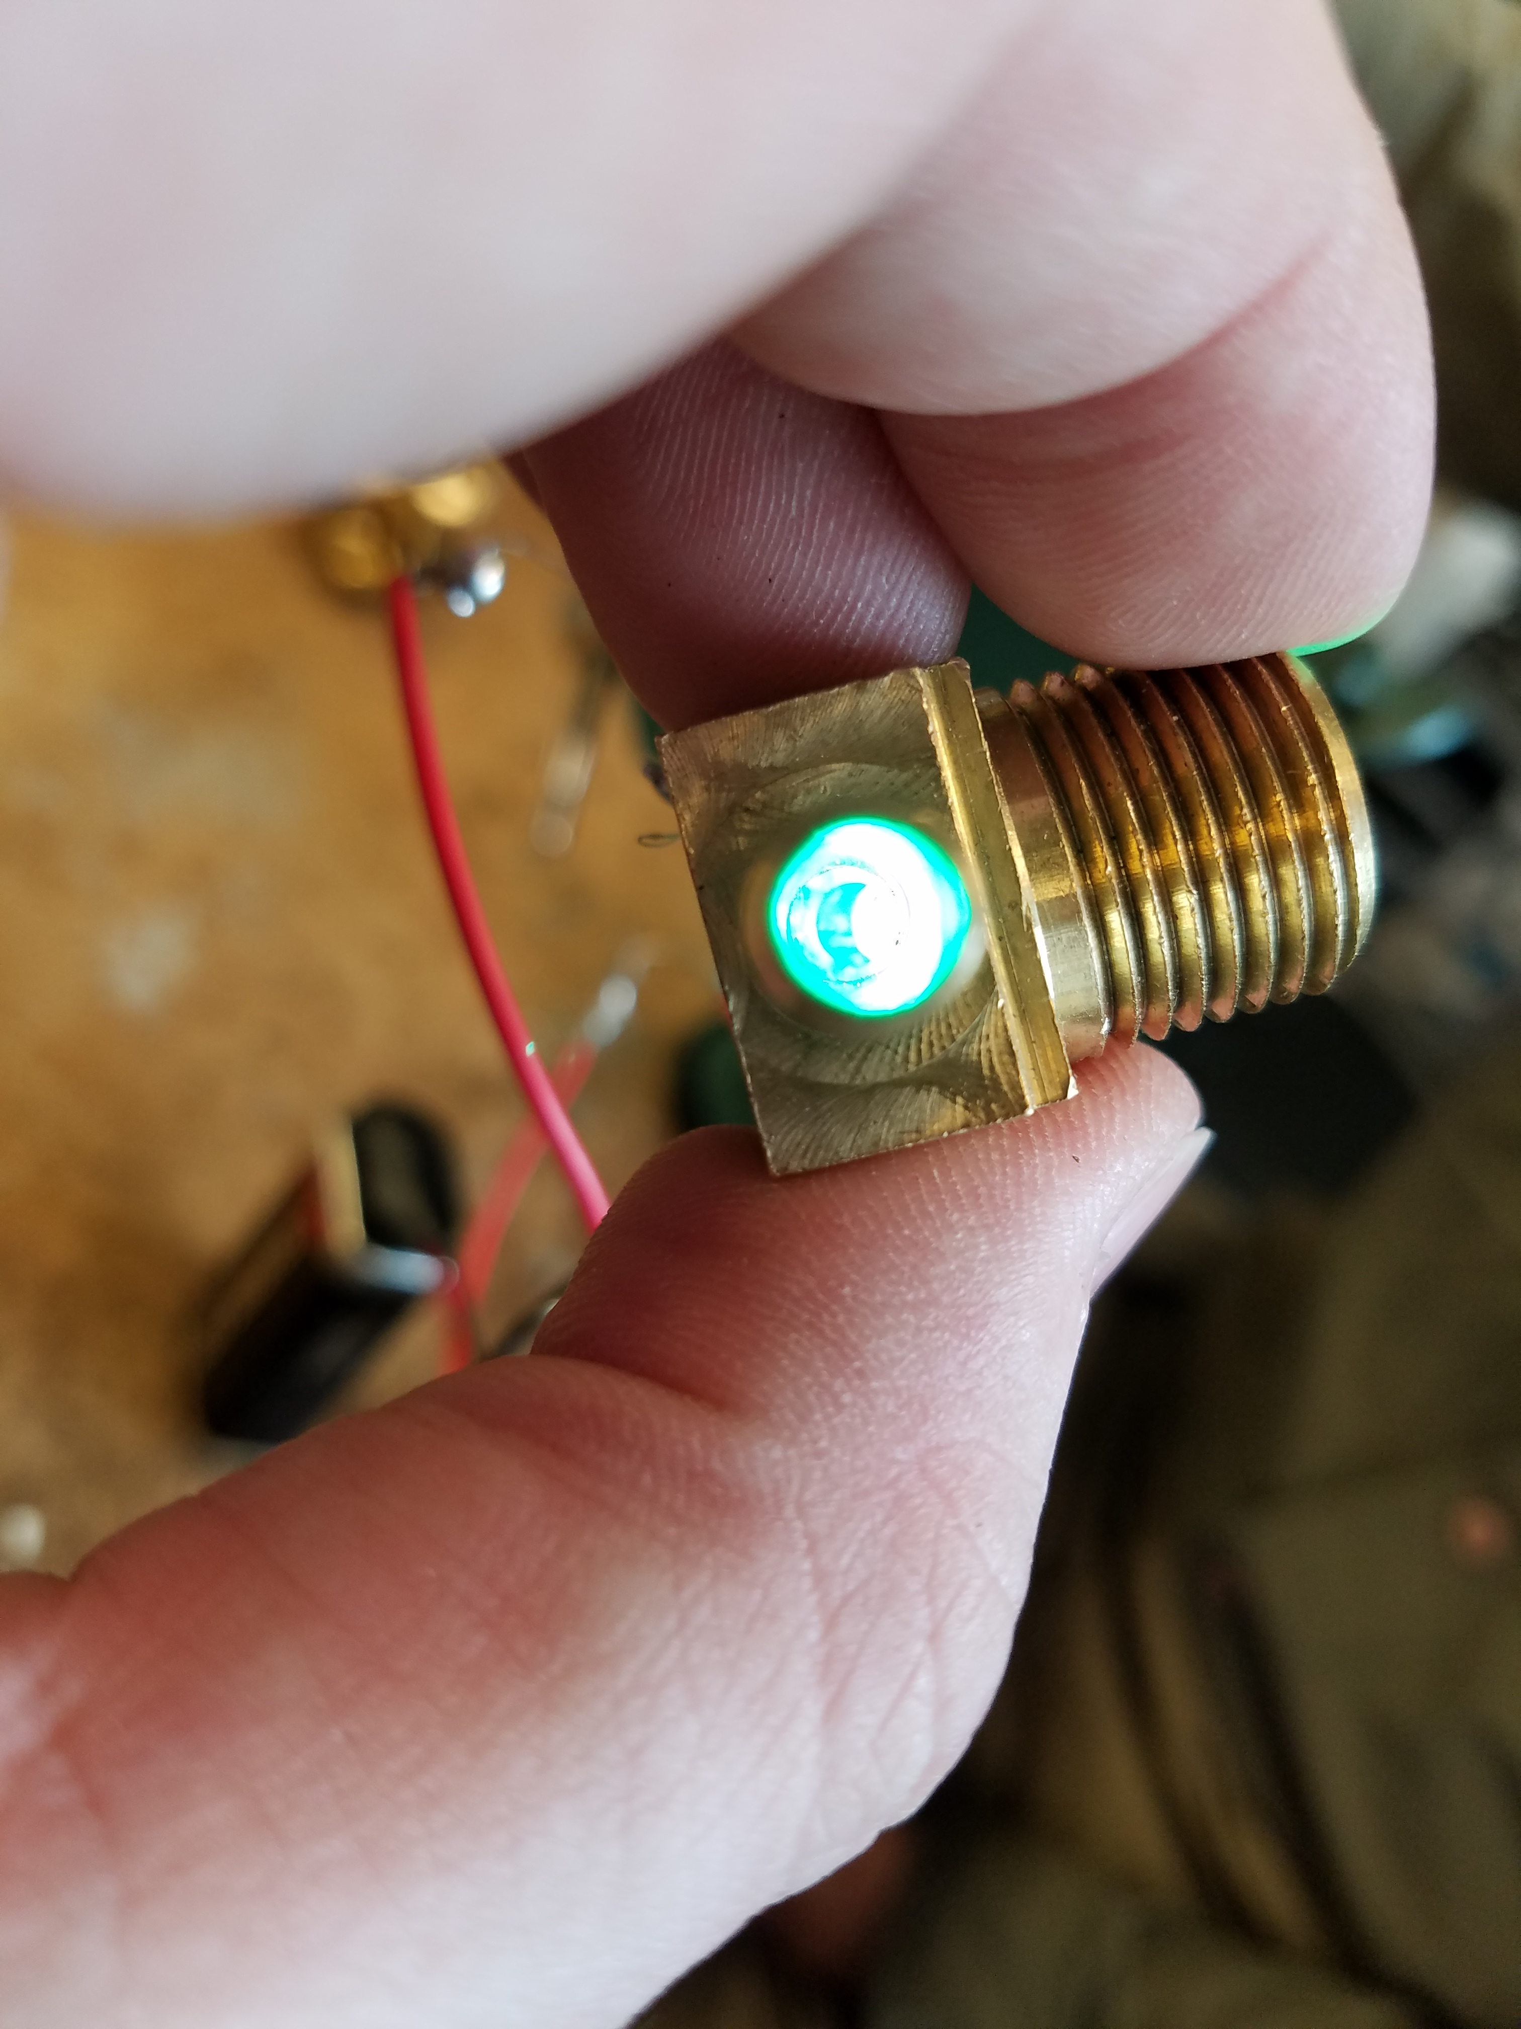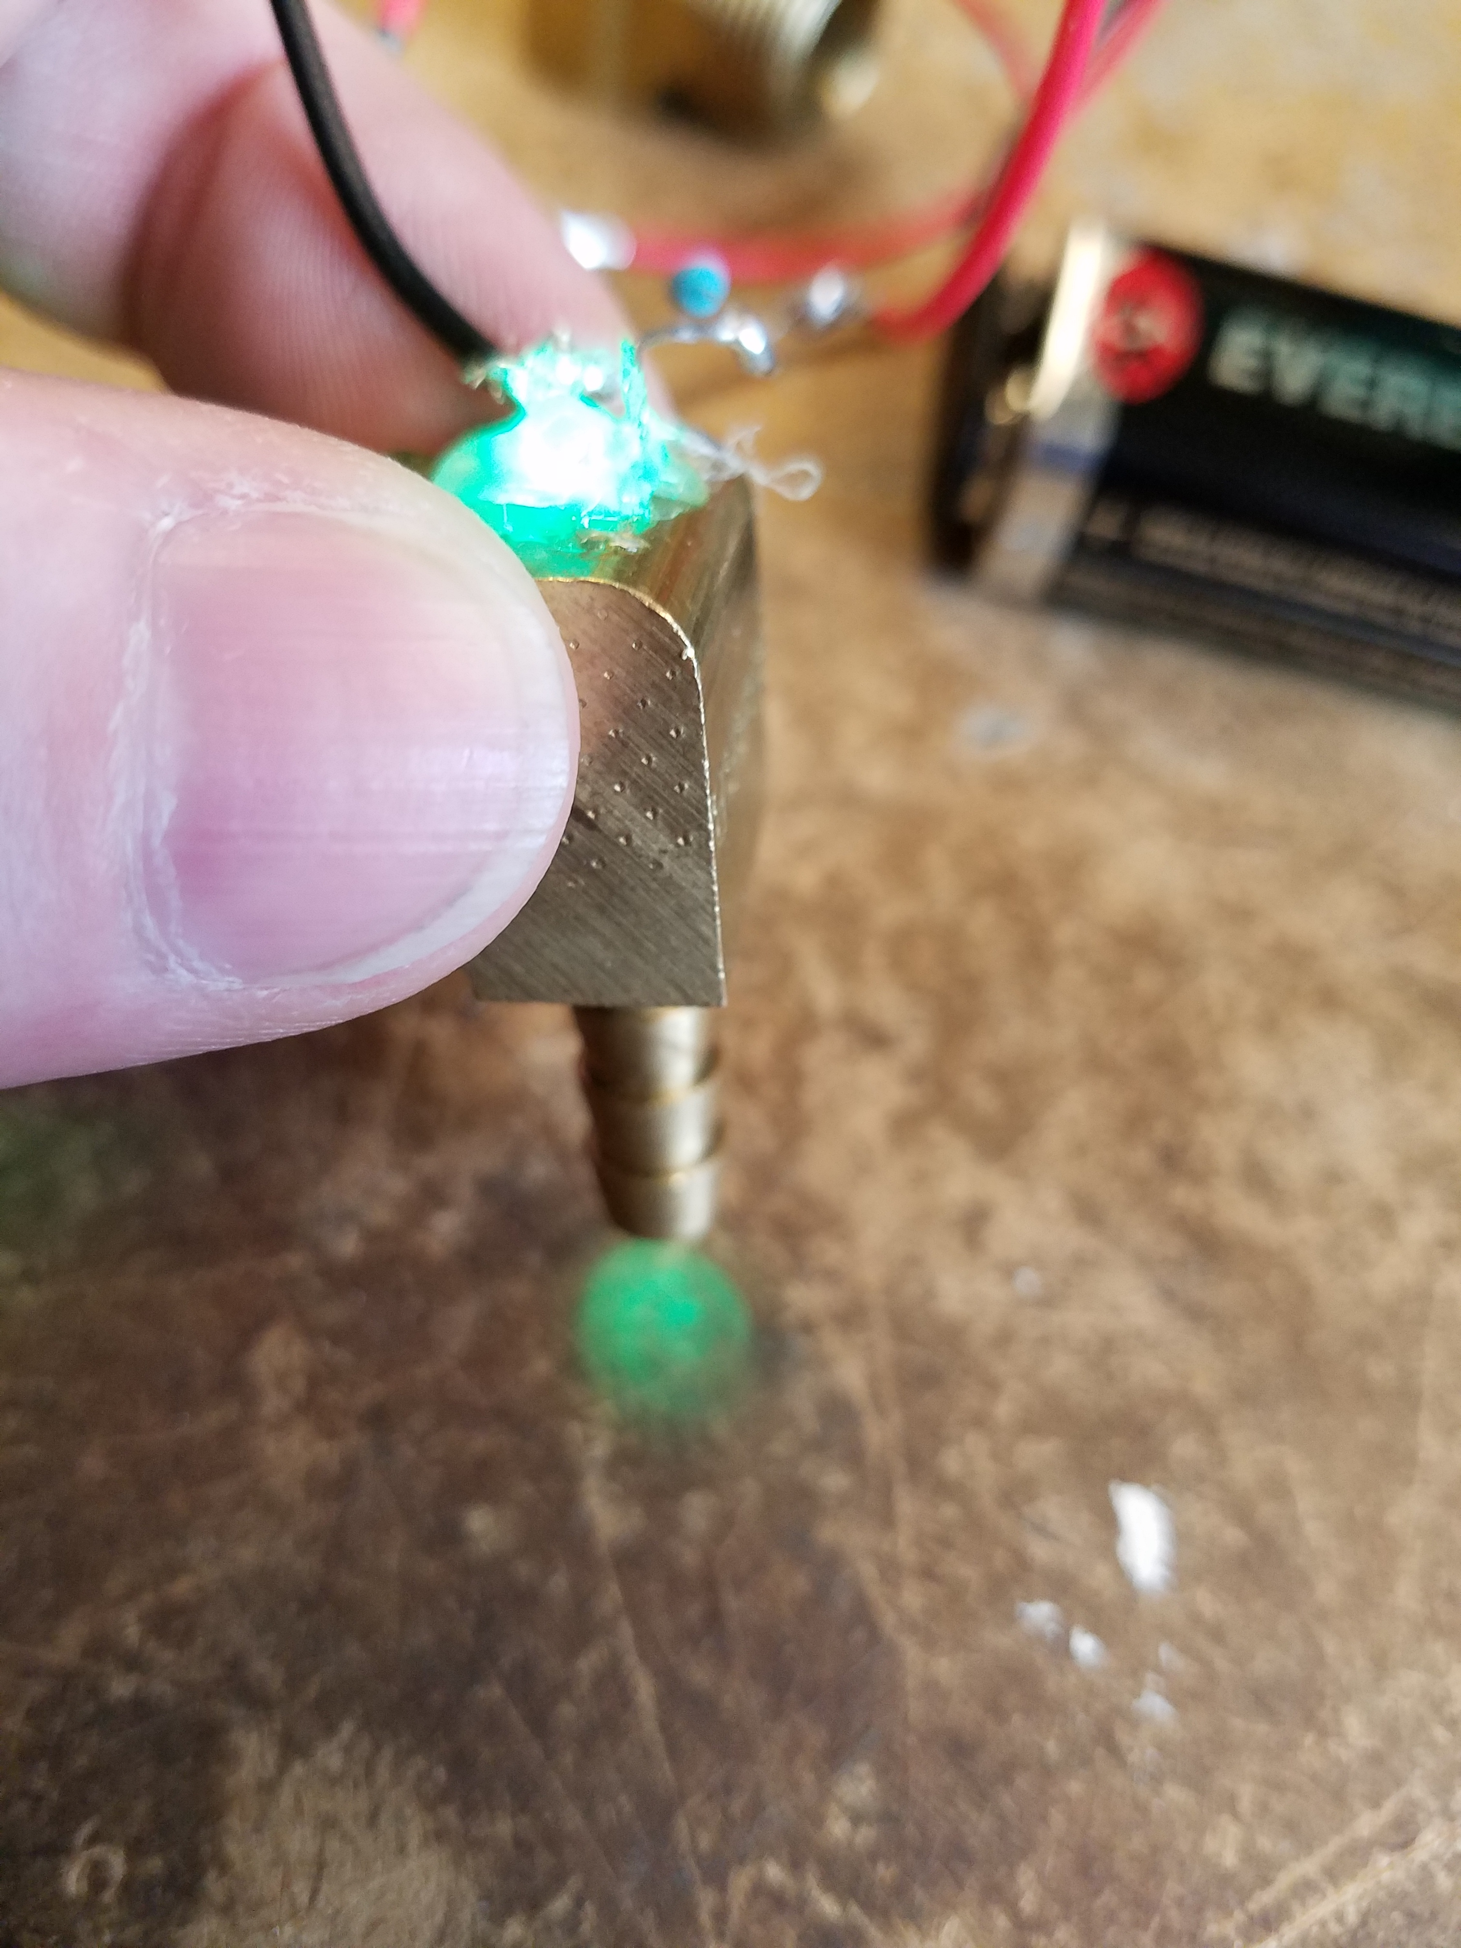

# Part Four: Adding Light to Liquid

1. 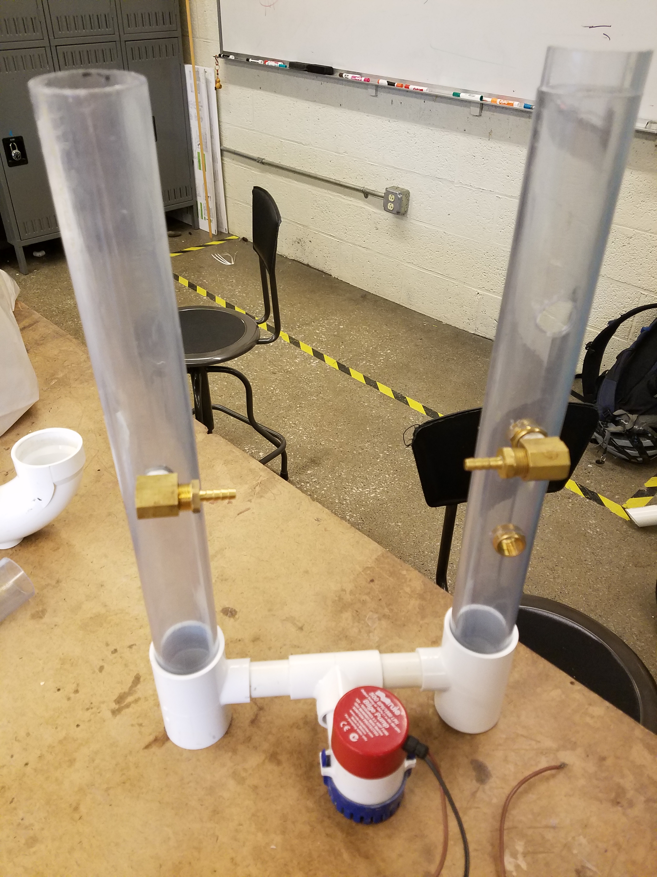Start by designing your setup, using your experience of water flow from part two. Consider what fittings can have LEDs added, and how much flow you want through each. A variant on our original design is shown on the right, and more examples in Appendix B.
2. Consider how to wire a setup with multiple LEDs. 9V batteries work well, but need to be kept out of the water. The 12V power supply for the bilge pump can be turned on and off, but different resistors will need to be used to make sure you don’t blow out the LEDs.
3. Consider how the streams of light will interact with one another. Colliding streams of water can make the light that each of them are “carrying” move in interesting ways.

# Appendix A: Tips and Tricks

* **Leaks around fittings**
  + First, check for whether the fittings are cross threaded (that the threads of the fitting don’t line up with the tap in the pipe). If the fitting is properly threaded, make sure it is screwed in tightly enough. If the fitting doesn’t sit facing the direction you want while tightened, you can add Teflon tape to adjust the fit.
* **Pump sputtering/low pressure**
  + Check the connection to the power supply and that the power supply is functioning normally. Then, add water to the reservoir to give the pump more to pull from.
* **Low pressure from nozzle**
  + Check to make sure the pump is working correctly (see above). Then, try using a tap that is lower down on your pipe. If the water is of a high enough pressure to be flowing over the top of your pipe, try extending the pipe higher (either by using a different piece or adding a new one via an in-line connector).
* **LEDs not lighting up**
  + Use your LED tester directly onto the legs of the LED, then slowly work backwards until you find a break in the circuit. You can also look at solder joints to see if anything has come loose. If you can’t get the LED to light up with the tester (make sure to check your polarity; see diagram in part three), it’s possible the LED is blown out. Check to make sure you have the appropriate resistor in your circuit before replacing it with a new LED.

# Appendix B: Examples

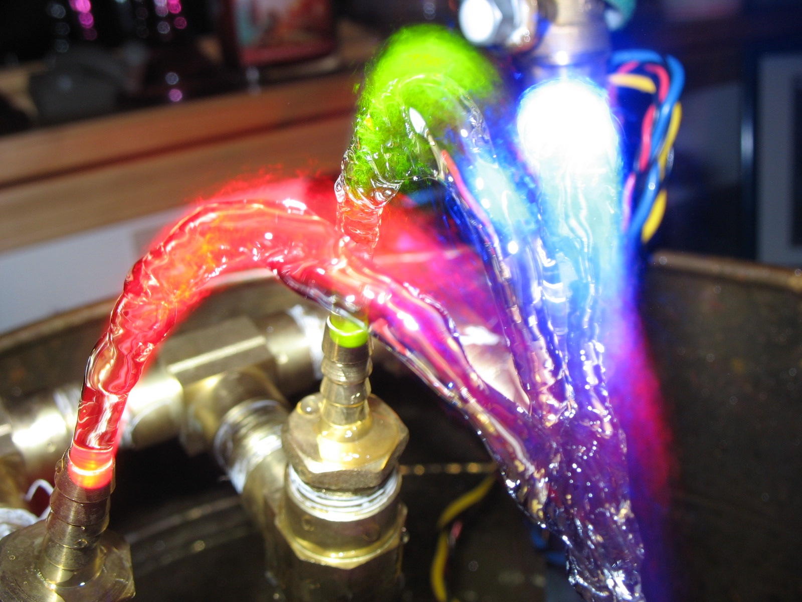

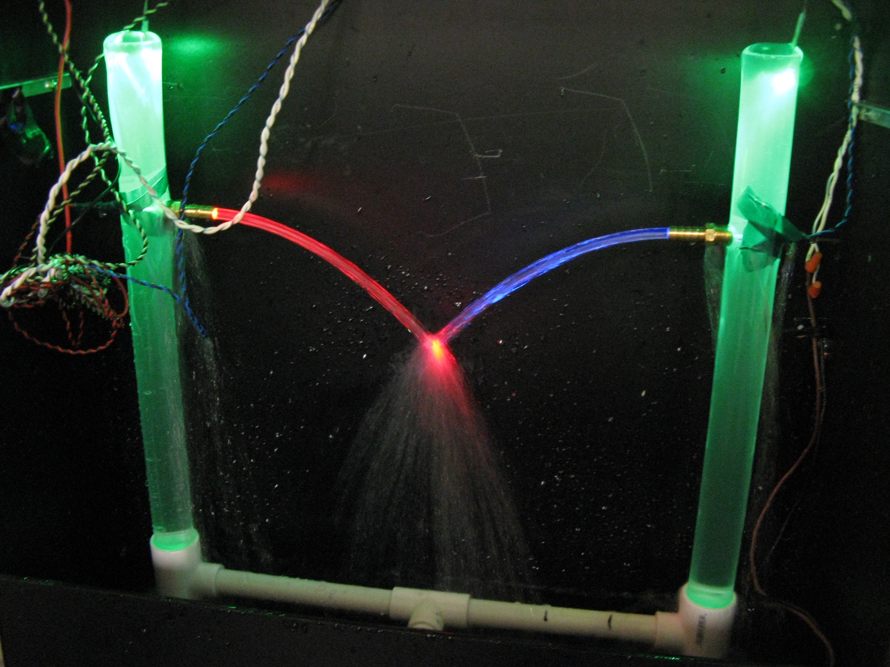

# Questions?

For questions/concerns, contact either Chris Mayer or Ed Moriarty (contact info below). Also feel free to send photos/video of your creations!

Chris Mayer

[mayerc@mit.edu](mailto:mayerc@mit.edu) (preferred)

617-324-7560

Ed Moriarty

[mory@mit.edu](mailto:mory@mit.edu)

339-223-9633 (preferred)